**Exercise 2.6.1**

1. 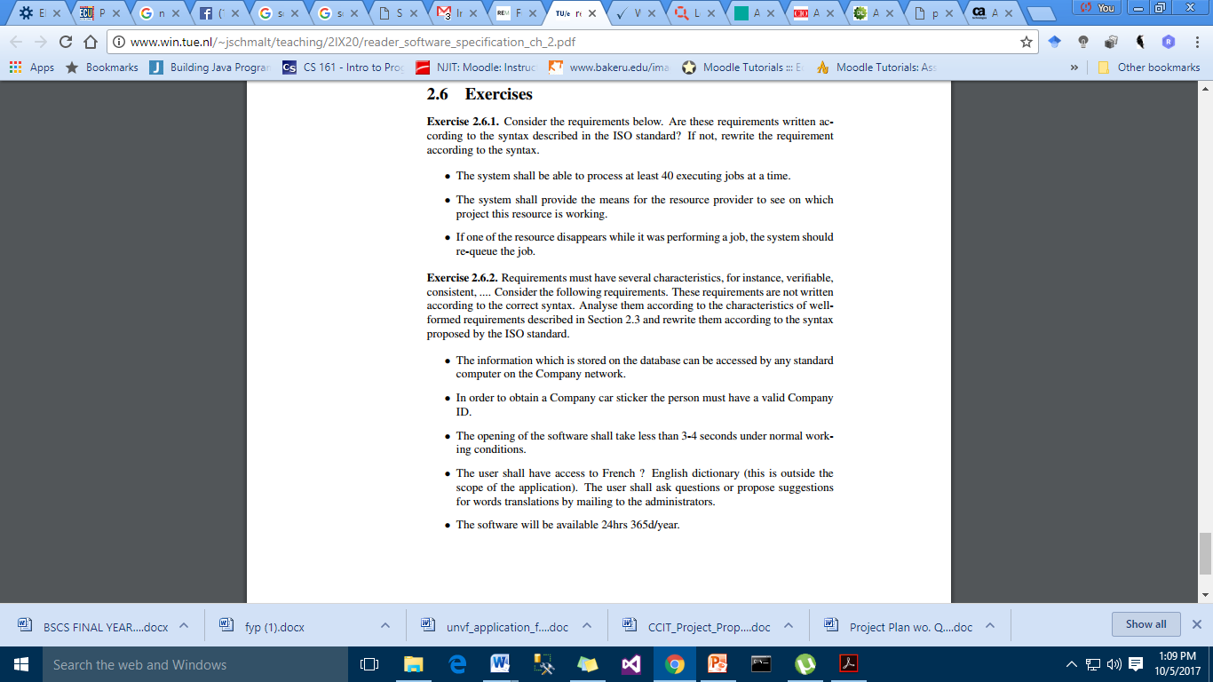The system shall be able to process at least 40 executing jobs at a time.

|  |  |
| --- | --- |
| Condition | At a time |
| Subject | The system |
| Action | Shall be able to process |
| Object | 40 executing jobs |
| Constraint | at least |

1. The system shall provide the means for the resource provider to see on which project this resource is working

|  |  |
| --- | --- |
| Condition | resource is working |
| Subject | The system |
| Action | Shall provide means |
| Object | Resource provider |
| Constraint | Which project the resource is working |

1. If one of the resource disappears while it was performing a job, the system would re-queue the job.

|  |  |
| --- | --- |
| Condition | If the resource disappears |
| Subject | The system |
| Action | The job |
| Object | Resource provider |
| Constraint | If the resource disappears while it was performing a job |

**Exercise 2.6.2**

|  |  |
| --- | --- |
| 1 | The database on the system shall store all the information that will only be accessible by computers on the Company Network. |
| 2 | The system shall provide the Company car sticker to the person if he has a valid Company ID. |
| 3 | If working conditions are normal, the software shall take less than 3-4 seconds to start. |
| 4 | The French English Dictionary shall provide access to the user. User shall send queries to the administrators via mail. |
| 5 | The software shall provide constant access for 24 hrs 365d/year.. |